Introducing Java Programming Concepts through Making a Retro-style Game

Ryan Young, Natalie Haney, Haniel Villarreal, Jaehyun Na

Advisors: Dr. Wei Jin, Dr. Xin Xu

[nhaney1@ggc.edu](mailto:nhaney1@ggc.edu), [jna@ggc.edu](mailto:jna@ggc.edu), [ryoung11@ggc.edu](mailto:ryoung11@ggc.edu), [hvillarreal@ggc.edu](mailto:hvillarreal@ggc.edu)

Georgia Gwinnett College

Lawrenceville, GA, U.S.A.

ABSTRACT

Students from the Technology Ambassadors Program (TAP) at Georgia Gwinnett College introduce basic programming concepts to online workshop participants by demonstrating and creating an interactive racing game using the Scratch programming language. The workshop encourages interest in the STEM fields, while teaching basic programming skills to control the game’s logic. Our study results showed that our workshops were successful and engaging.

CCS CONCEPTS

• Interactive Java Learning

KEYWORDS

outreach, programming, online, block coding, teaching, IT, CS, education, project-based learning

ACM Reference Format:

Ryan Young, Natalie Haney, Haniel Villarreal, Jauhyun Na

Advisors: Dr. Xin Xu, Dr. Wei Jin

Introducing Programming Concepts through Interactive Online Workshops. In Proceedings

of the 22nd Annual Conference on Information Technology Education USB

Stick (SIGITE ’21), October 6–9, 2021, SnowBird, UT, USA. ACM, New York,

1 INTRODUCTION

Our goal is to encourage learning in IT and Software Development by demonstrating the simplicity at the core of the field, and showing how to build a product up from small pieces. This is done through an outreach program, implemented at several institutions, that have demonstrated the importance in developing interest in STEM at an early age.

2 METHODOLOGY

In order to encourage students and help them gain confidence in programming we had them create a simple version of our game. The idea was to break down a portion of the code and have students work with processing to move a square left and right. Only having one object to move is less daunting than a whole finished video game which can make students feel overwhelmed. It also demonstrates the creative freedom that they can now do using processing with just the little bit of information they had learned. Being able to instantly see the results of your code and having the code broken down into more manageable pieces was hopefully going to help students feel comfortable to program and also excited to learn more.

3 RESULTS

To see how beneficial our workshop was we had students take a pre- and post-survey to compare their confidence and attitude towards programming and if they were now interested in taking a programming related course. We asked a few beginner friendly questions to the students about programming topics and all in all the students did fantastic at identifying variables and data types. The feedback to our workshop follows:

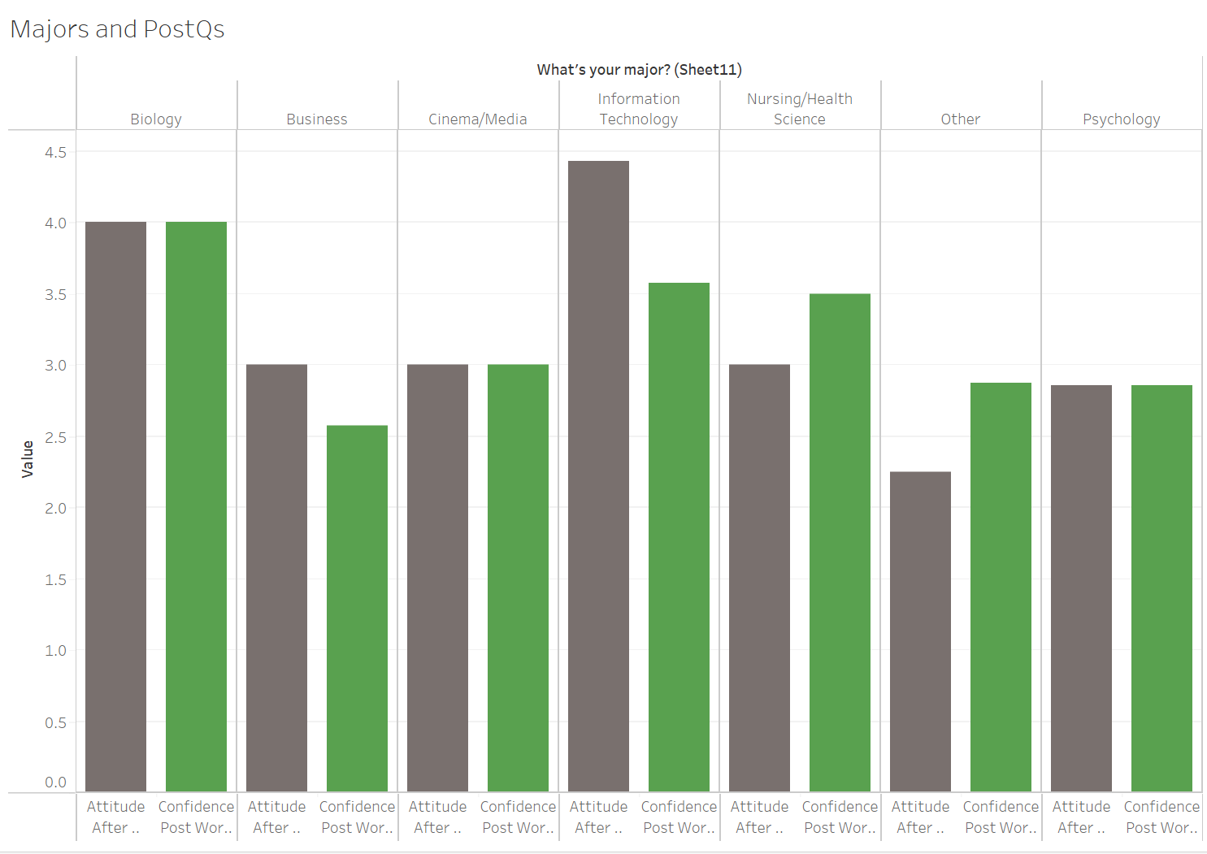

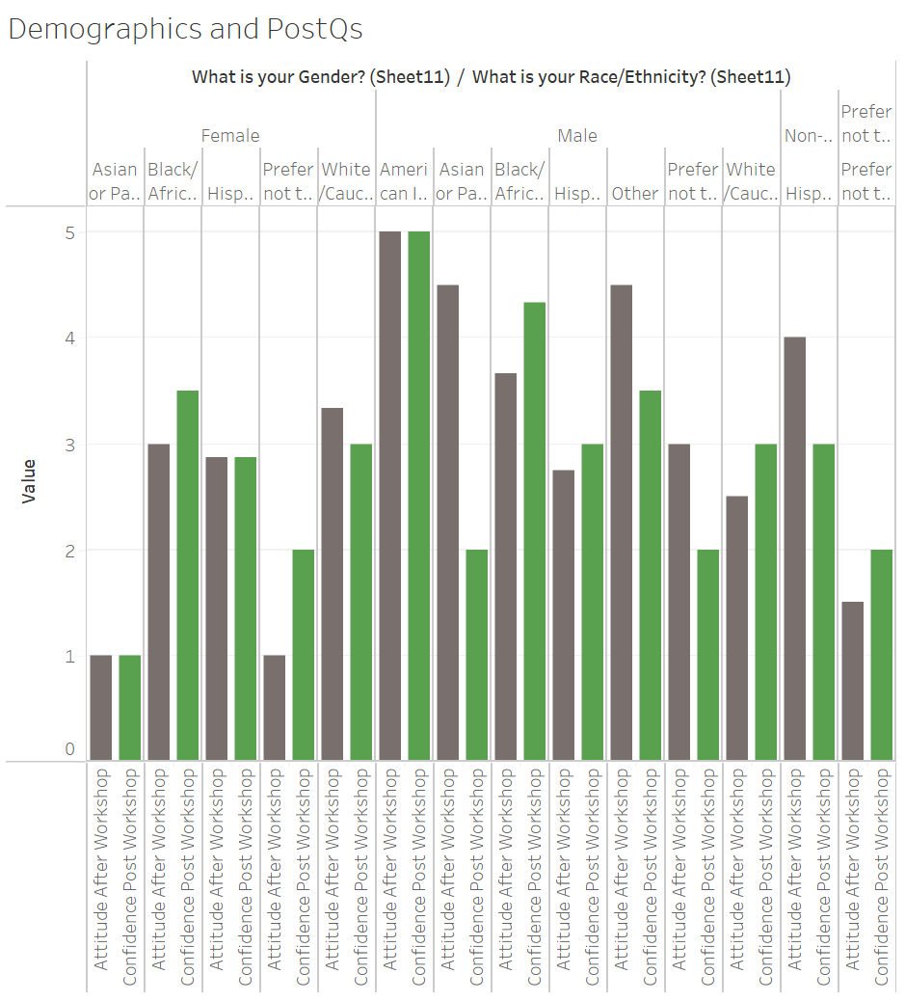

The above two graphs show the attitudes of the students after they took our workshop, divided by major, then by race and gender. The race and gender chart is skewed towards male somewhat just because of the small sizes of the classrooms and how most students were male. Overall, attitudes and confidence were high across the board after our workshop as evidenced by the other graph that separates by major only.

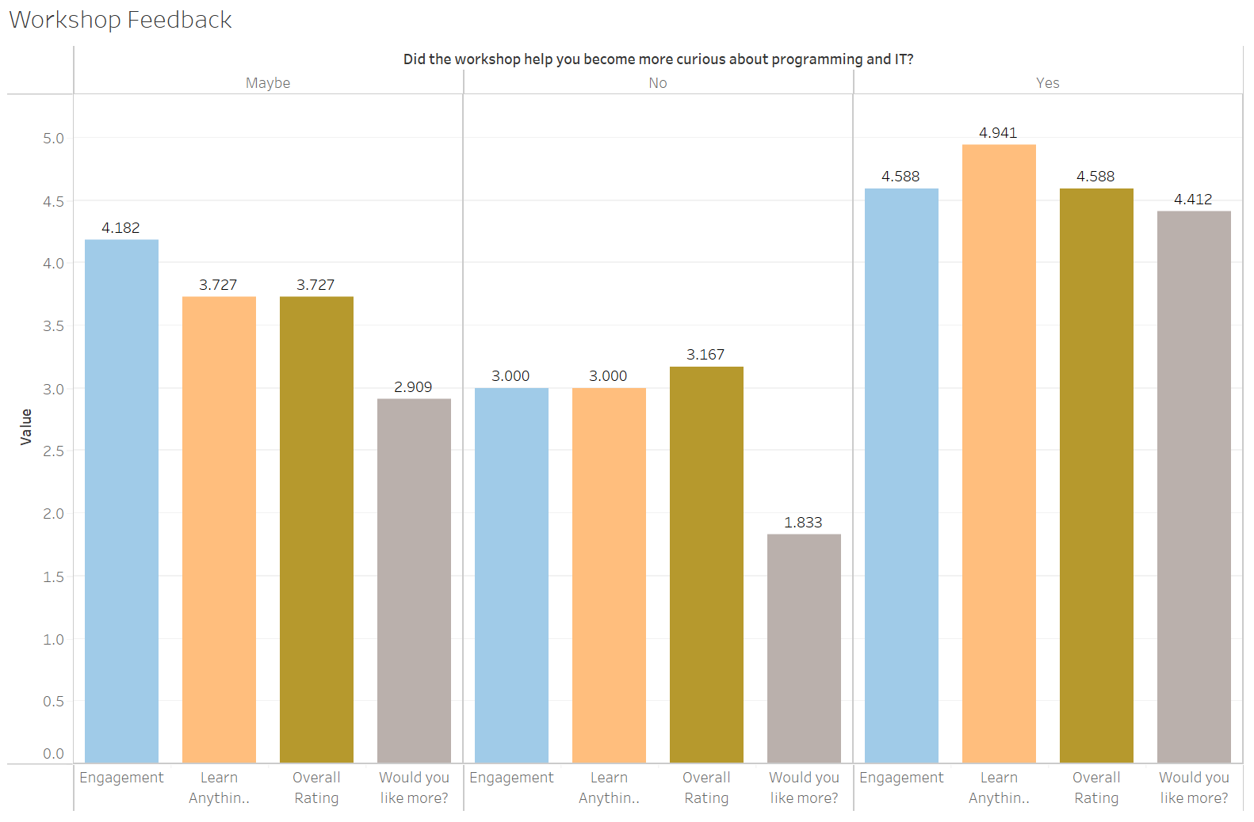

This graph shows workshop feedback, separated by the question if they were going to take a programming class in the future. A majority of students found the workshop engaging, stating that they learned something and overall enjoyed it.

4 DISCUSSION

Based on the responses to our survey and our interaction with the students, we conclude we achieved our goal to gather some interest in IT and show people that it is not as daunting as it may seem. It was instilled in us how important good communication was, as well as patience especially. The ability to spend ten minutes troubleshooting is an important skill to have, especially when dealing with new programmers and helping to keep them from becoming overly frustrated. It was also important to work on our feet, adjust as necessary. By the third time we gave our workshop, we had the process down, and based on our survey responses we were effective instructors.

We had gone back and forth in developing our workshop, varying complexity and how much to include. The simple tasks we ended up with was a strong introduction to java, while also allowing us to keep within our time restraints and the ability level of our students.

How we worked together as a team was something difficult to get into, but ended up strong. Teamwork was essential as everyone in the group has a different skill level and different strengths. It was essential to delegate skills both fairly in terms of time, but also in skill level, and we believe we were effective in that manner.

5 CONCLUSION

We conclude that our space invaders game and matching workshop succeeded in showing how a complex product could be made up of ultimately simple building blocks, and that programming was not as difficult or daunting as it appears on the surface. Our students coded from scratch, ended up with a final product on their own, and left with some base skills and interest to build further in the future.